Assignment - 2
Module 2 – Introduction to Programming
- Write an essay covering the history and evolution of C programming. Explain its importance and why it is still used today ?
- History and Evolution of C Programming :-
- C Programming language was developed by Dennis Ritchie In the early 1970s at Bell Laboratories.
- It was created to develop the UNIX Operating system.
- C evolved from earlier languages like B and BCPL.
- In 1973, UNIX was rewritten in C , which made C very popular.
- The language was later standardize as ANSI C (1989) and improved versions like C99 and C11.
- Importance of C Programming :-
- C is a fast and efficient language.
- It provides low-level access to memory using pointers.
- Used for system programming, operating system and embedded system.
- Many modern operating systems like Windows, Linux and macOS use C.
- Why C Is Still Used Today :-
- C Program runs faster than many high-level languages.
- It is portable, meaning it works on many platforms.
- A large amount of existing software is written in C.
- C is the base language for many other languages like C++, Java and Python.
- It helps programmers understand how computers work internally.
- Research and provide three real-world applications where C programming is extensively used, such as in embedded systems, operating systems, or game development. - LAB EXERCISE
- Below explanation :-
- Operating Systems :-
- C is widely used to develop operating system.
- Major OS Component Like Linux, Windows and macOS are written largely in C.
- C is fast and efficient.
- It provides direct access to hardware and memory.
- Example :- Linux Kernel is mostly written in C.
- Embedded Systems :-
- C is the most popular language for embedded systems.
- Used in devices like :-
- Washing Machine
- Microwave Ovens
- Medical Devices
- Cars
- C uses less memory
- Works well on low-power hardware
- Examples:- Microcontrollers like Arduino and PIC use C Programs.
- Game Development :-
- C is used in Game Engine and performance-critical parts of games.
- C offers high performance.
- Allows efficient graphics and memory handling.
- Examples :- Game Engine like Unity (core parts) and unreal engine (low-level systems) use C/C++.
- Describe the steps to install a C compiler (e.g., GCC) and set up an Integrated Development Environment (IDE) like DevC++, VS Code, or CodeBlocks.
- Steps to Install a C Compiler (GCC) :-
- Download GCC :-
- Windows :- Download MinGW or TDM-GCC
- Install the compiler :-
- Run the installer and follow default steps
- Set Path (Windows Only) :-
- Add the bin folder of GCC to Environment Variables -> Path
- Verify Installation :-
- Open Command Prompt / Terminal
- Type: GCC –version.
- Steps to Set Up Dev-C++ IDE :-
- Download Dev-C++ :-
- Download from the official Dev-C++ website.
- Install Dev-C++ :-
- Run setup and finish Installation
- Configure Compiler :-
- Dev-C++ usually detects GCC automatically
- Go to Tools -> Compiler Options if needed.
- Create First Program :-
- File -> New -> Source File
- Write C code and save with .c extension.
- Compile & Run :-
- Click Compile & Run (F11).
- Install a C compiler on your system and configure the IDE. Write your first program to print "Hello, World!" and run it. - LAB EXERCISE
- Input :-
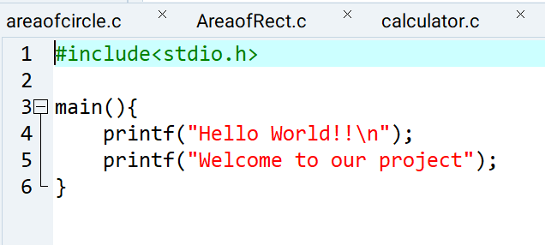

Output :-
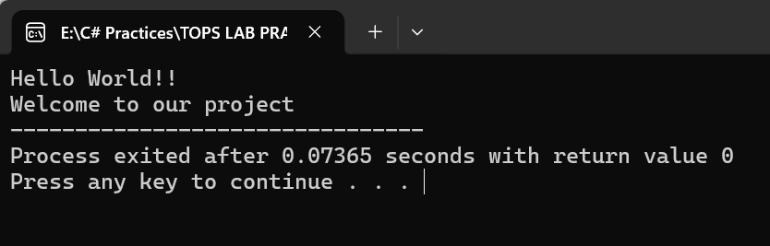
- Explain the basic structure of a C program, including headers, main function, comments, data types, and variables. Provide examples.
- Basic structure of C program :-
- Header Files :-
- Header files can contain built-in functions and definitions.
- They are included using #include.
- Example :- #include<stdio.h> is used for input/output functions like printf().
- Main Function :-
- main() function where programs start execution.
- It must return an int value.
- Return 0; when program ran successfully.
- Example :-
Int main(){
return 0;
}
- Comments :-
- Comments explain the code and ignored by compiler.
- There are two types of comments :-
- Single line of comments (//)
- Multiple line of comments (/**/)
- Example :-
//Hello World
/*12345
Hello guys!
*/
- Data Types and Variables :-
- Variables can store data and must have a data type.
- Common data types :-
Int Whole Number
Float Decimal Number
Double more Precise Decimals
Char Single character
- Example :-
int age = 14;
float num = 23.4;
double dl = 34.56;
char ch = ‘Y’;
- Write a C program that includes variables, constants, and comments. Declare and use different data types (int, char, float) and display their values. - LAB EXERCISE
- Input :-
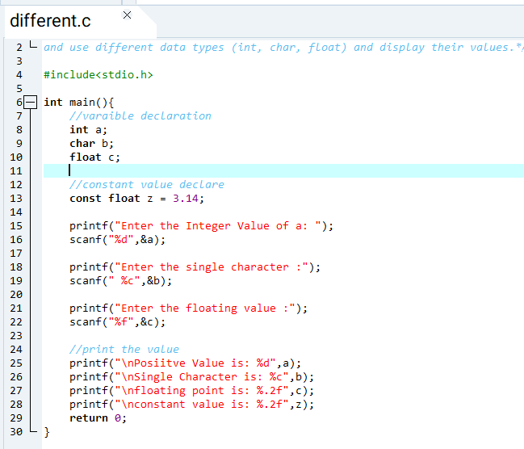
Output :-
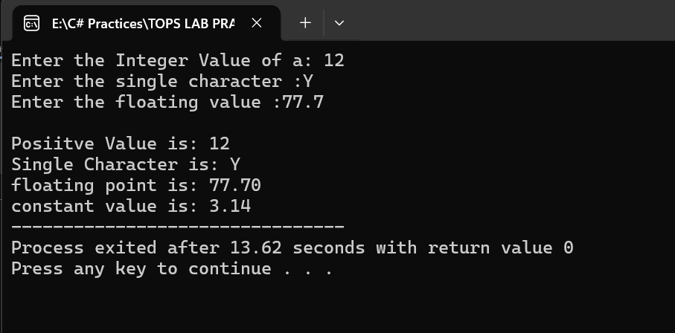
- Write notes explaining each type of operator in C: arithmetic, relational, logical, assignment, increment/decrement, bitwise, and conditional operators.
- Here’s Below the explanation of operator
- Arithmetic Operator :-
Operator | Name | Description | Example
+ | Addition | Add Two Operands. | 5 + 2 = 7
- | Subtraction | Subtract right operands from left | 5 – 2 = 3
* | Multiplication | Multiplies by Two Operands | 5 * 2 = 10
/ | Division | Divides left operands from right | 5 / 2 = 2.5
% | Modules | Return the reminder of an integer division | 5 % 2 = 0.1

- Relational Operator :-
Operator | Name | Description | Example
== | Equal to | Check if two operands are equal. | 5 == 2 evaluates to 0 (false)
!= | Not Equal to | Check if two operands are not equal | 5 == 2 evaluates to 0 (false)
< | Less than | Checks if left operand is less than right | 5 < 2 evaluates to 0 (false)
> | Greater than | Checks if left operand is greater than right | 5 > 2 evaluates to 1 (true)
<= | Less than or Equal to | Checks if left operand is less than or equal to | 5 <= 2 evaluates to 0 (false)
>= | Greater than or Equal to | Checks if left operand is greater than or equal to | 5 >= 2 evaluates to 1 (true)

- Logical Operator :-
Operator | Name | Description | Example
&& | Logical AND | Return 1 if both the conditions are true. | (5 > 2) && (2 < 5) evaluates to 1
|| | Logical OR | If one condition are true than true otherwise false | Logical OR
! | Logical NOT | Reverses the logical state of an operand | (5 == 2) evaluates to 1

- Assignment Operator :-
Operator | Name | Description | Example | Equivalent to
= | Assignment | Assign the value on right to the variable on the left | a = 5 | a = 5
+= | Add and Assign | Adds right operand to the left operand and assigns the result to the left. | a+=2 | a = a + 2
-= | Subtract and Assign | Subtracts right operand from the left operand and assigns the result to the left. | a-=2 | a = a - 2
*= | Multiply and Assign | Multiplies right operand with the left operand and assigns the result to the left. | a*=2 | a = a * 2
/= | Divide and Assign | Divides left operand by the right operand and assigns the result to the left. | a/=2 | a = a / 2
%= | Modules and Assign | Takes modulus using two operands and assigns the result to the left operand. | a%=2 | a = a % 2

- Increment/Decrement Operators :-
Operator | Name | Description | Example
++ | Increment | Increases the integer value by one. | ++a (prefix) or a++ (postfix)
-- | Decrement | Decrement the integer value by one. | --a (prefix) or a-- (postfix)

- Bitwise Operator :-
Operator | Name | Description
& | Bitwise AND | Sets each bit to 1 if both bits are 1.
| | Bitwise OR | Sets each bit to 1 if either of the bits is 1.
^ | Bitwise XOR | Sets each bit to 1 if only one of the bits is 1.
~ | Bitwise Complement | Inverts all the bits of the operand.
<< | Left shift | Shifts the bits of the left operand to the left by the number of positions specified by the right operand.
>> | Right shift | Shifts the bits of the left operand to the right by the number of positions specified by the right operand.

- Conditional Operators :-
Operator | Name | Syntax | Description | Example
?: | Conditional | condition ? expression1 : expression2 | If the condition is true (1), expression1 is executed; otherwise, expression2 is executed. | Result = (marks >=60)? ‘pass’ : ‘fail’

- Write a C program to check if a number is even or odd using an if-else statement. Extend the program using a switch statement to display the month name based on the user’s input (1 for January, 2 for February, etc.). - LAB EXERCISE
- Input :-
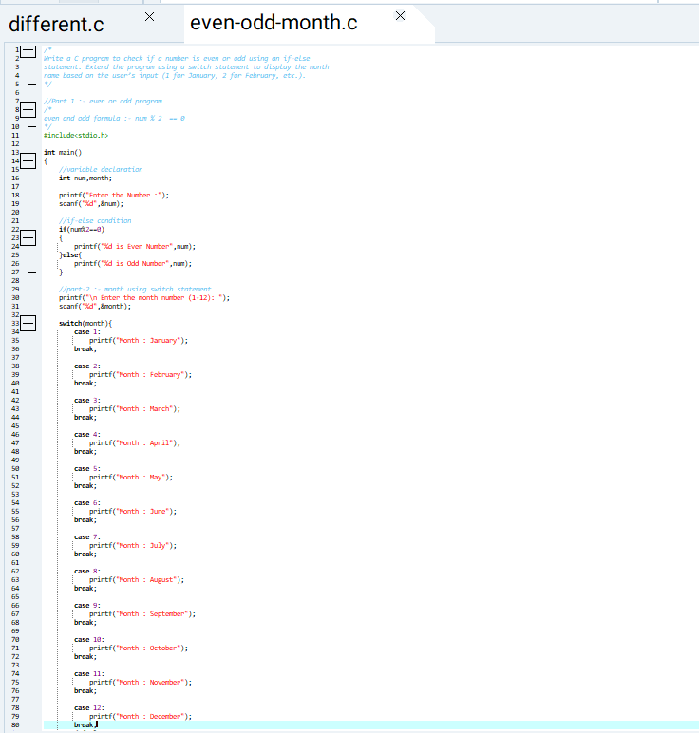
Output:-
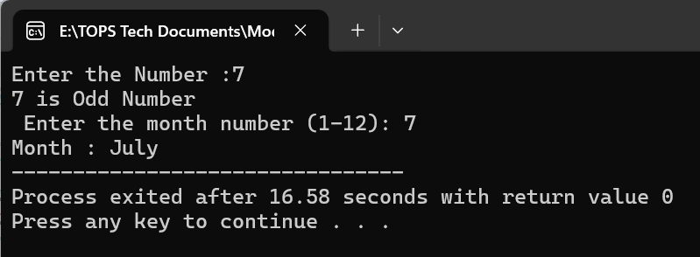
- Explain decision-making statements in C (if, else, nested if-else, switch). Provide examples of each.
- Decision making statement :-
- If Statement :-
- Executes a block of code only if the condition is true.
- Example :-
If(age>18){
Printf(“eligible for voting”);
}
- If-else Statement :-
- Executes one block if the condition is true.
- Executes another block if the condition is false.
- Example :-
If(age>=18){
Printf(“Eligible for voting”);
}else{
Printf(“Not Eligible for voting”);
}
- Nested if-else :-
- An if-else statement inside another if-else
- Used for check multiple condition.
- Example :-
If(marks>=90){
Printf(“Grade A”);
}else if(marks>=75){
Printf(“Grade B”);
}else{
Printf(“Grade C”);
}
- Switch Statement :-
- Used when there are multiple fixed choices for a single variable.
- Use Case, break and default.
- Example :-
Switch(day){
Case 1:
Printf(“Monday”);
Break;
Case 2:
Printf(“Tuesday”);
Break;
Default:
Printf(“Invalid Day”);
Break;
}
- Compare and contrast while loops, for loops, and do-while loops. Explain the scenarios in which each loop is most appropriate.
- Here’s the below the difference:-
Feature | While loop | For loop | Do While loop
Condition Check | Checked before each iteration | Checked before each iteration | Checked after each iteration
Minimum Execution | 0 times | 0 times | At least one time
Loop Structure | Condition only | Initialization, Condition and Modification | Body-first and Condition Last
Risk of infinite loop | Medium | Low | Medium
Typical Syntax Style | While(condition) | For(Initialization; condition; modification) | Do { } while(condition)

- Scenario and most appropriate loop :-
- While loop :-
- Scenario :-
- You don’t know how many times the loop should run.
- Monitoring the changing system state.
- For loop :-
- Scenario :-
- You are iterating fixed number of times.
- Traversing an array or list with an index.
- Do While loop :-
- Scenario :-
- You need to loop body to execute at least once.
- Write a C program to print numbers from 1 to 10 using all three types of loops (while, for, do-while). - LAB EXERCISE
- While loop :-
Input :-
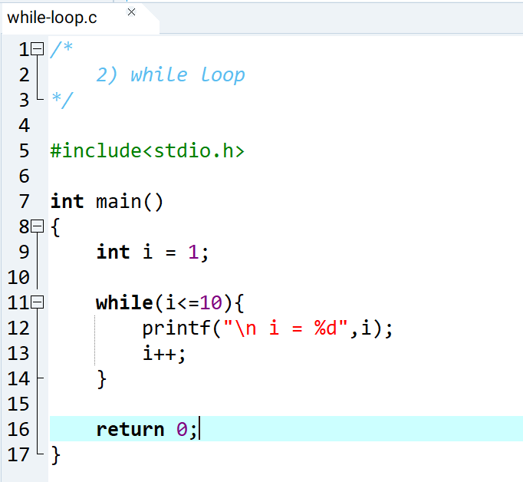
Output:-
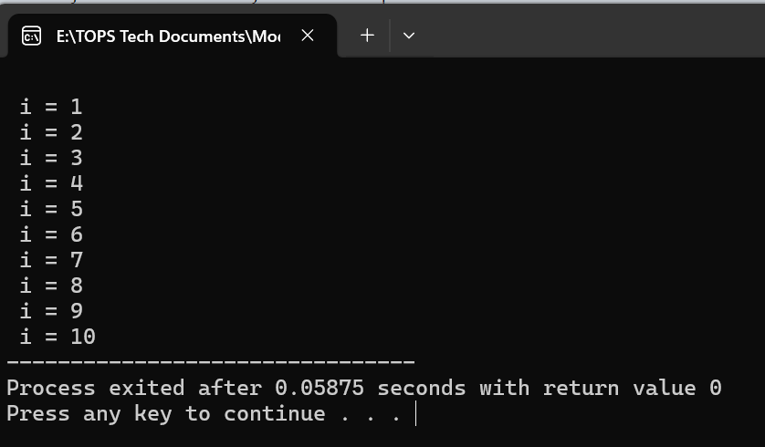
- For loop :-
Input:-
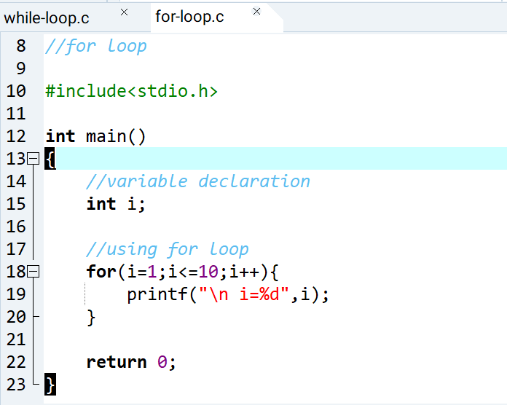
Output:-
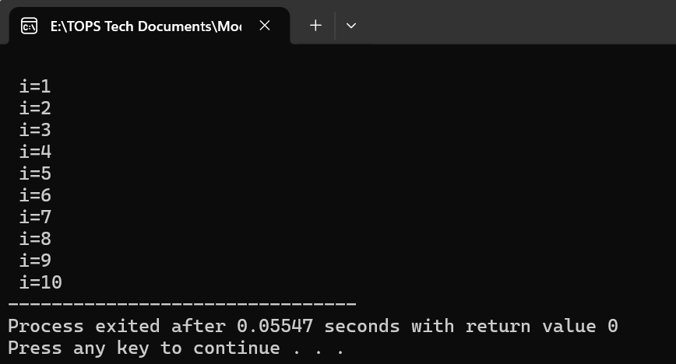
- Do While loop :-
Input:-
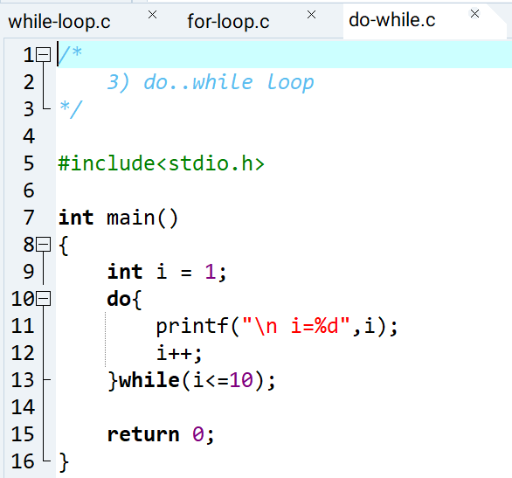
Output:-

- Explain the use of break, continue, and goto statements in C. Provide examples of each.
- Below the Explanation of each :-
- Break Statement :-
- Used to terminate a loop or switch statement immediately.
- Control goes to the statement after the loop or switch.
- Where to used :- for, while, do..while and switch.
- Example :-
Input:-
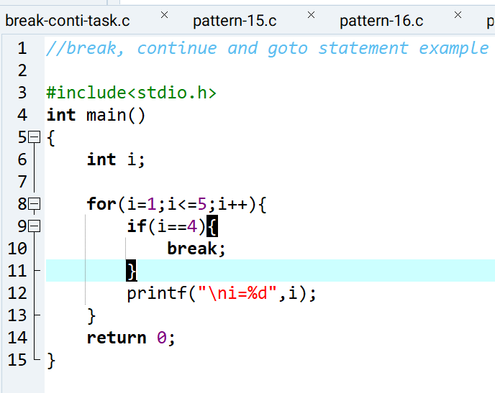
Output:-
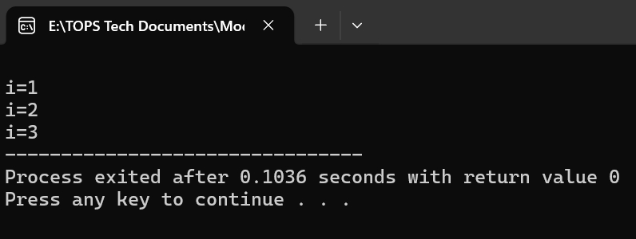

- Continue Statement :-
- Used to skip current iteration of loop.
- Loop continues with the next iteration.
- Where to used :- for, while, do..while and switch.
- Example :-
Input:-
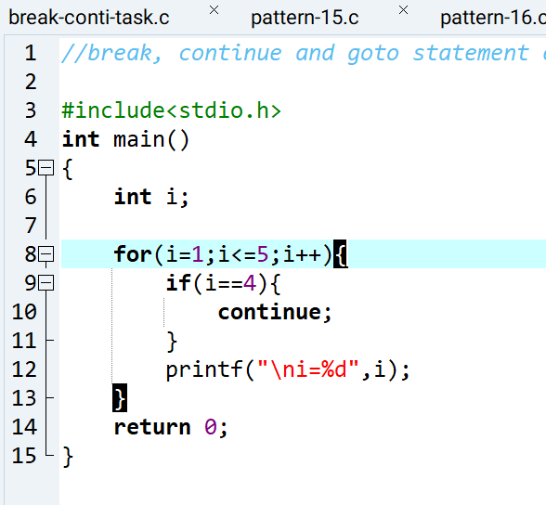
Output:-
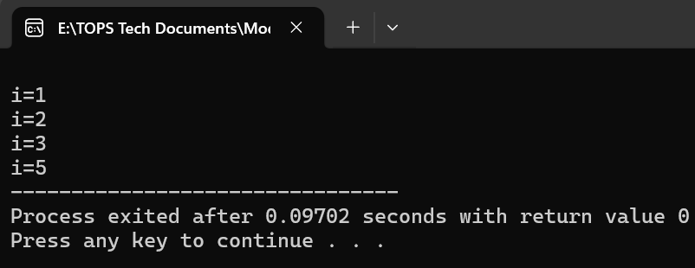

- Goto Statement :-
- Used to jump a specific label within a same function.
- Example :-
Input:-
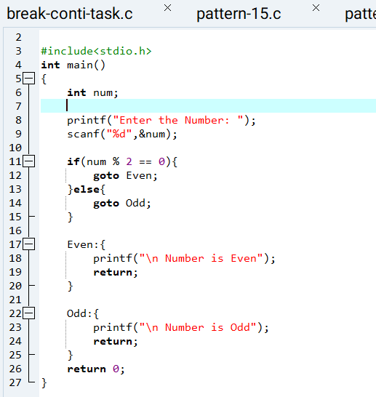
Output:-
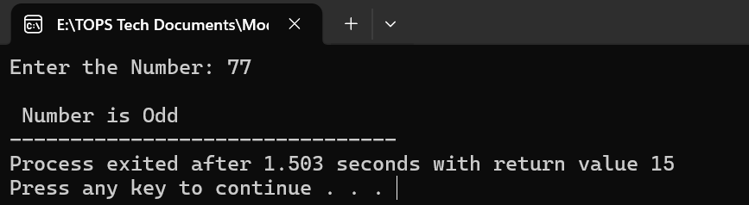

- Write a C program that uses the break statement to stop printing numbers when it reaches 5. Modify the program to skip printing the number 3 using the continue statement. - LAB EXERCISE
- Below the Input and output :-
Input:-
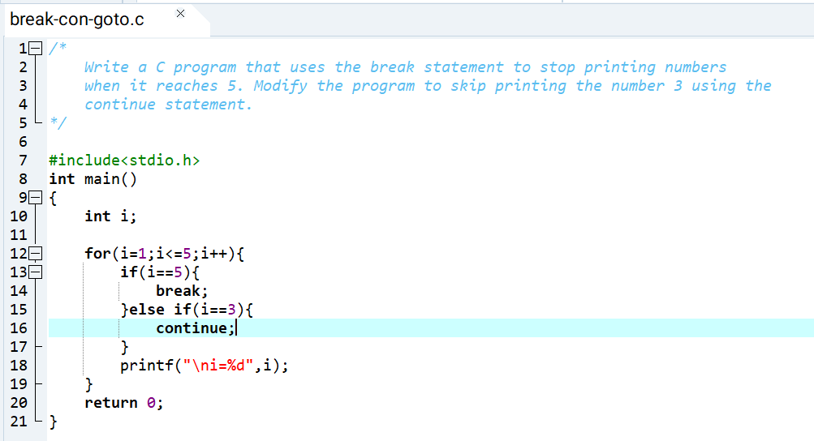
Output:-
Break Statement Output:-
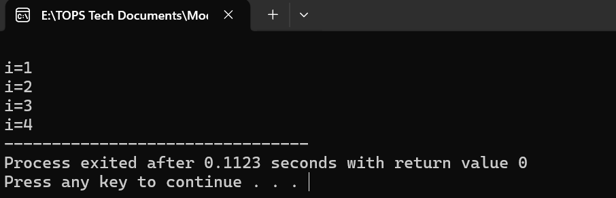
Continue Statement Output:-
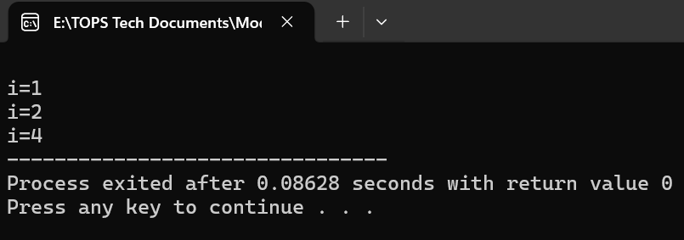
- What are functions in C? Explain function declaration, definition, and how to call a function. Provide examples.
- A functions is a block of code that perform a specific tasks.
- It helps divide the big problems into smaller parts.
- Every C program has at least one function – main().
- Function Declaration :-
- Tells the compiler the function is exist.
- Specifies
- Return type
- Function name
- Parameters written before main()
Syntax :- return type function_name(p1,p2,p3);
Example:- int add(int,int);
- Function Definition :-
- Contain actual code of the function.
- Written after main() or before it.
Syntax :-
Return type function_name(parameters){
//code
}
Example :-
Int add(int a, int b){
Return a + b;
}
- Function call :-
- Used to execute the function
- Can be called from main() or another function
Syntax:-
Function_name(arguments);
Example:-
Sum = Add(10,20);
Program Example :-
Input:-
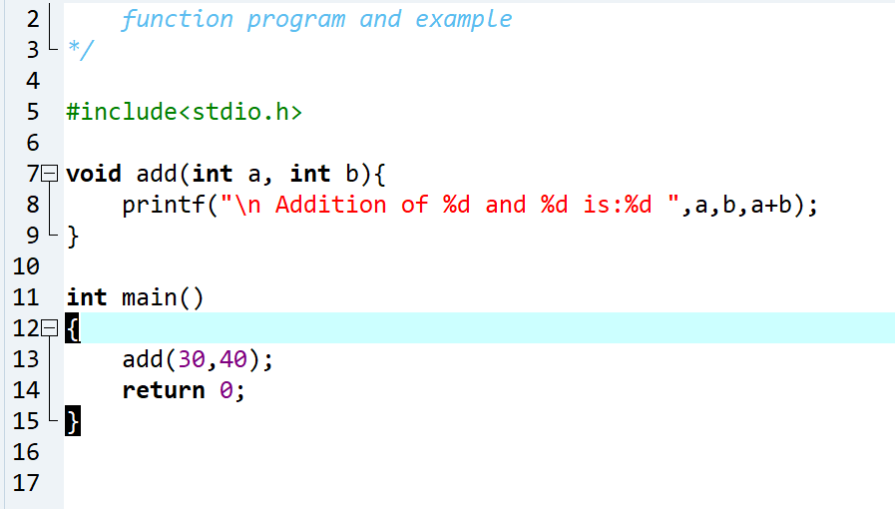
Output:-
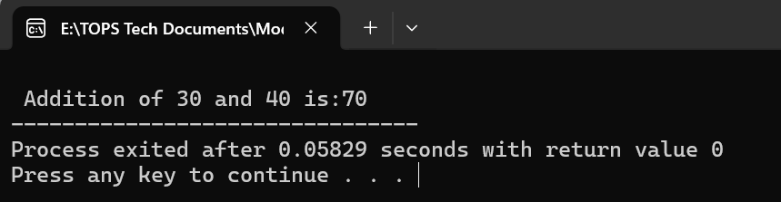
- Write a C program that calculates the factorial of a number using a function. Include function declaration, definition, and call.
- Input:-
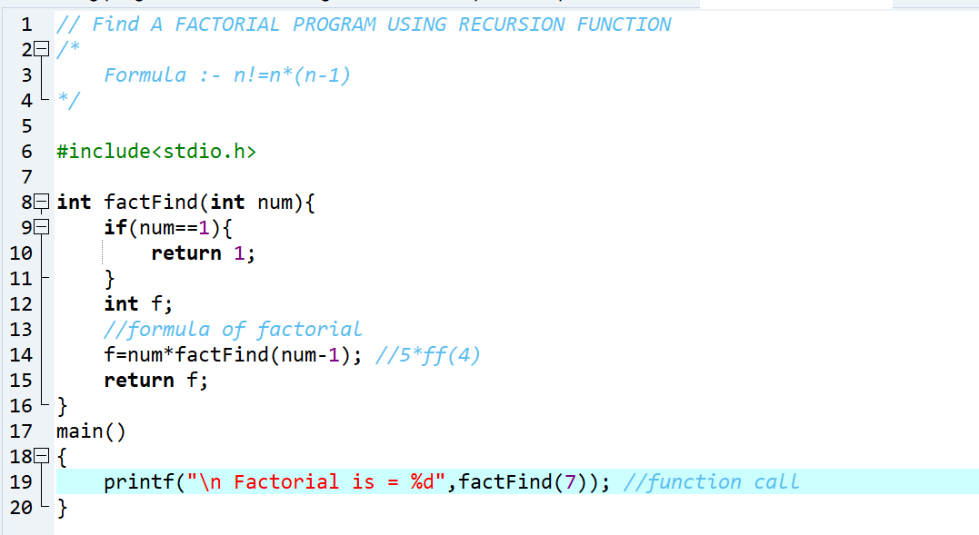
Output:-
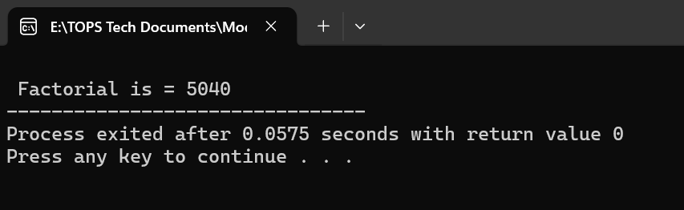
- Explain what pointers are in C and how they are declared and initialized. Why are pointers important in C?
- Pointer :- pointer is a variable that stores the address of the another variable.
- Declaration of pointer :-
Syntax :- data_type *pointer_name;
Example :- int *p; => *p is a pointer variable
- Initialization of a pointer :-
Int a = 10;
Int *p;
p=&a;
- Pointers are very important :-
- Dynamic Memory allocation
- Passing argument by reference
- Efficient array and string handling
- Building complex data structure.
- Low-level memory access.
- Write a C program to demonstrate pointer usage. Use a pointer to modify the value of a variable and print the result. - LAB EXERCISE
- Input:-
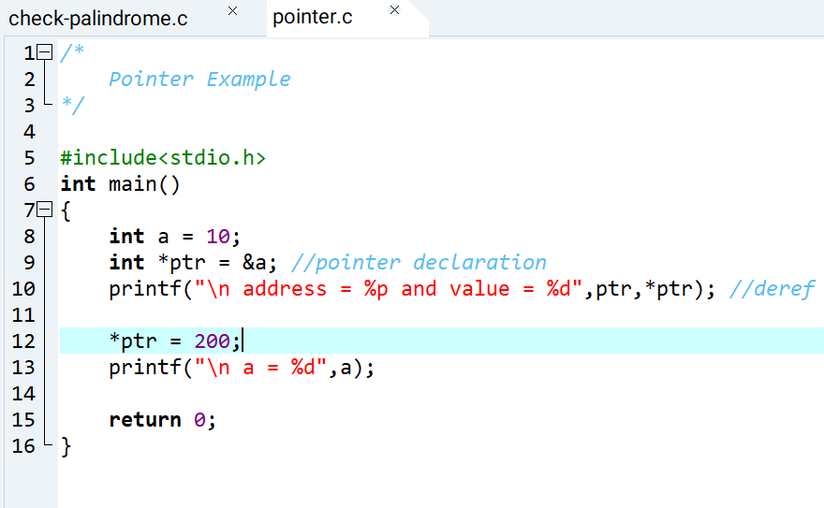
Output:-
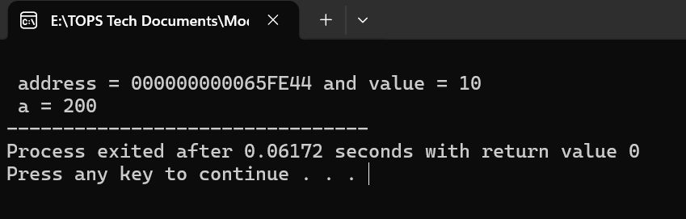
- Explain the concept of arrays in C. Differentiate between one-dimensional and multi-dimensional arrays with examples.
- Array is used to store a collection of data, and it is often used as a collection variables of same data type that is known as array.
- There are basically two types of array
- One Dimensional Array
- Two Dimensional Array (2-D Array)
Syntax of Array :- datatype array_name[size];
Difference between one-dimensional and multi-dimensional array :-
One Dimensional Array | Two Dimensional Array (2-D)
An array with only one index | An array with more than one index
Datatype array_name[size]; | Datatype array_name[size1][size2];
Using one index access method : arr[i] | Using multiple indices access method: arr[i][j]
Stored sequentially in memory | Stored in row-major order
Using linear list structure | Using table(2D), cube(3D) etc.
Example :- int a[5]; | Example:- int b[3][5];

Example :-
Input :-
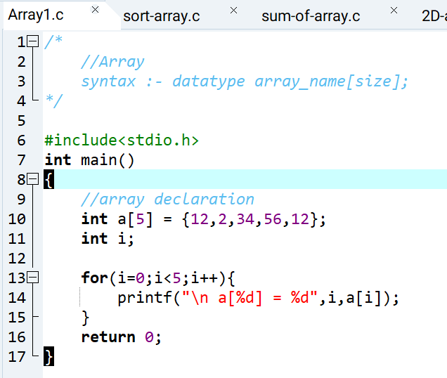
Output:-
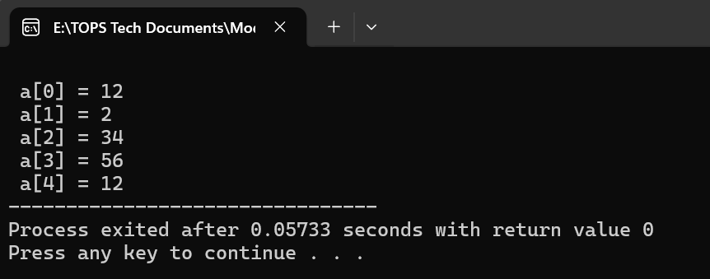
- Write a C program that stores 5 integers in a one-dimensional array and prints them. Extend this to handle a two-dimensional array (3x3 matrix) and calculate the sum of all elements. - LAB EXERCISE
- Input:-
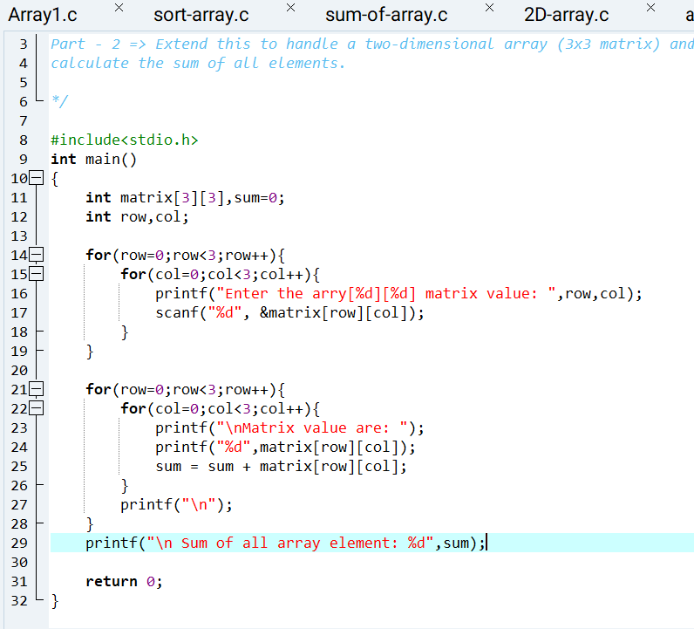
Output:-
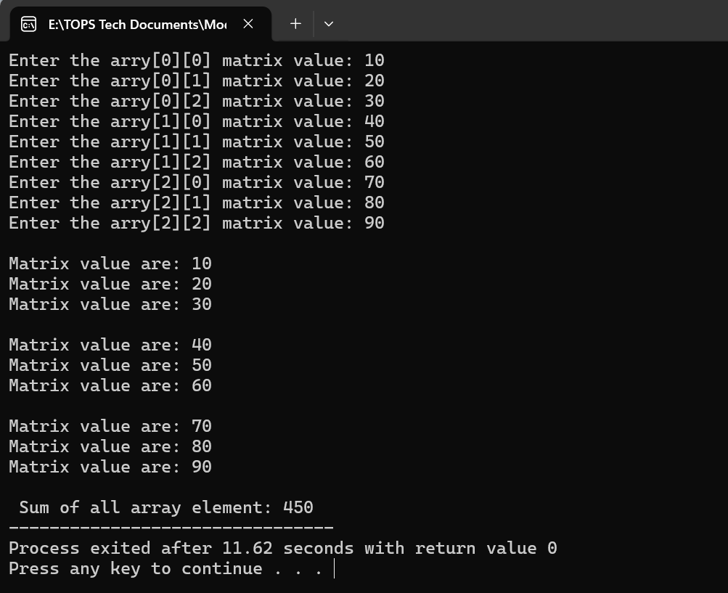

- Explain string handling functions like strlen(), strcpy(), strcat(), strcmp(), and strchr(). Provide examples of when these functions are useful.
- Below the string handling :-
- Strlen():- return the length of a string, not counting null character
Example :-
Input:-
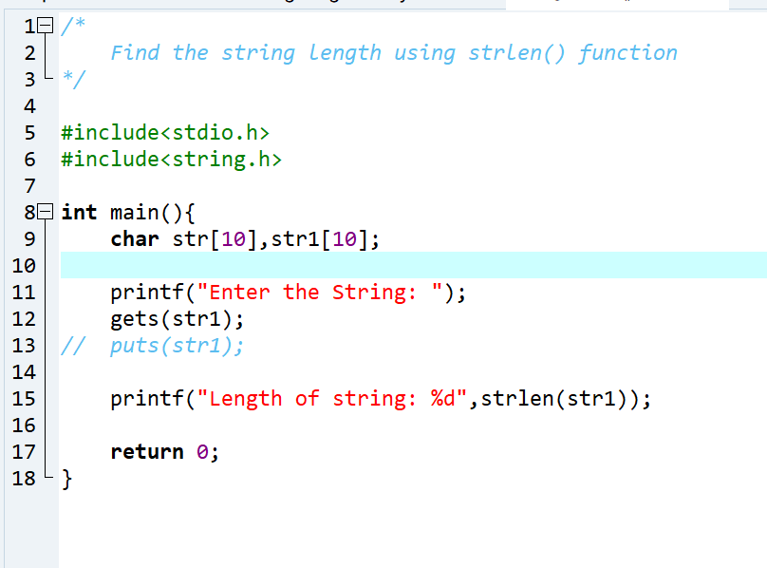

Output:-
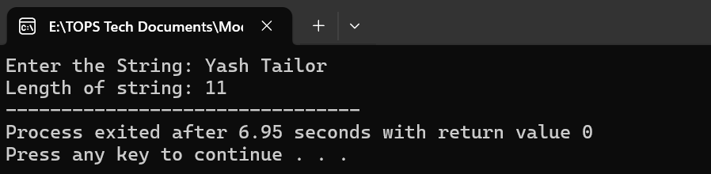

- Strcpy():- Copy One string to another.
Example :-
Input:-
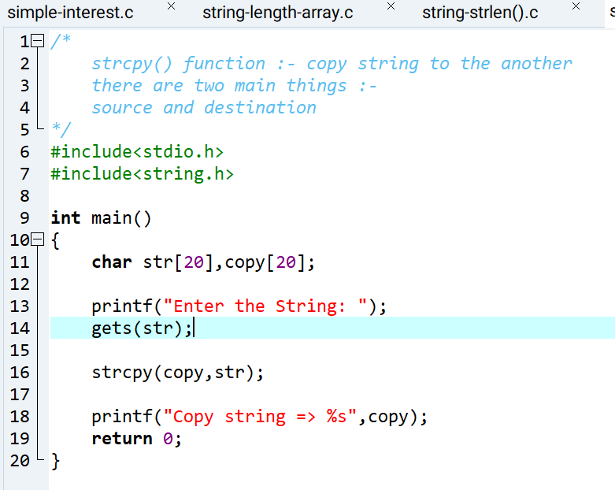
Output:-
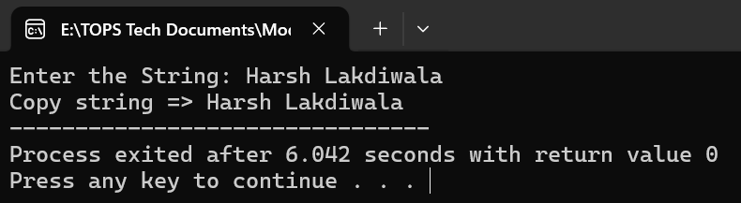
- Strcat() :- Append one string to another, creating a single string out of two.
Example:-
Input:-
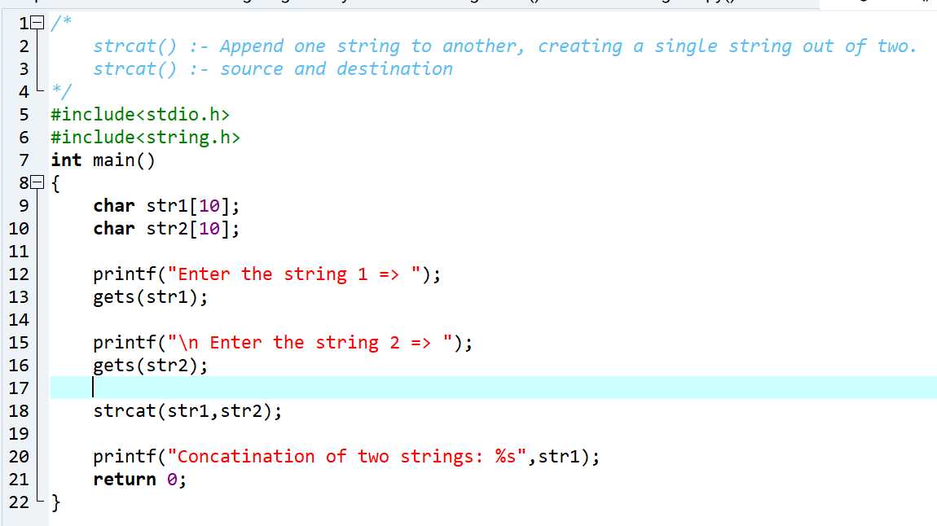
Output:-
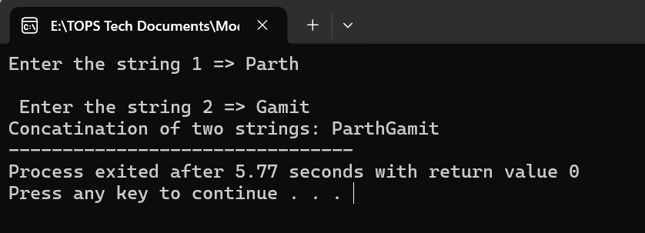
- Strcmp():- Compare two strings. If the string match , the function returns 0.
Example :-
Input:-
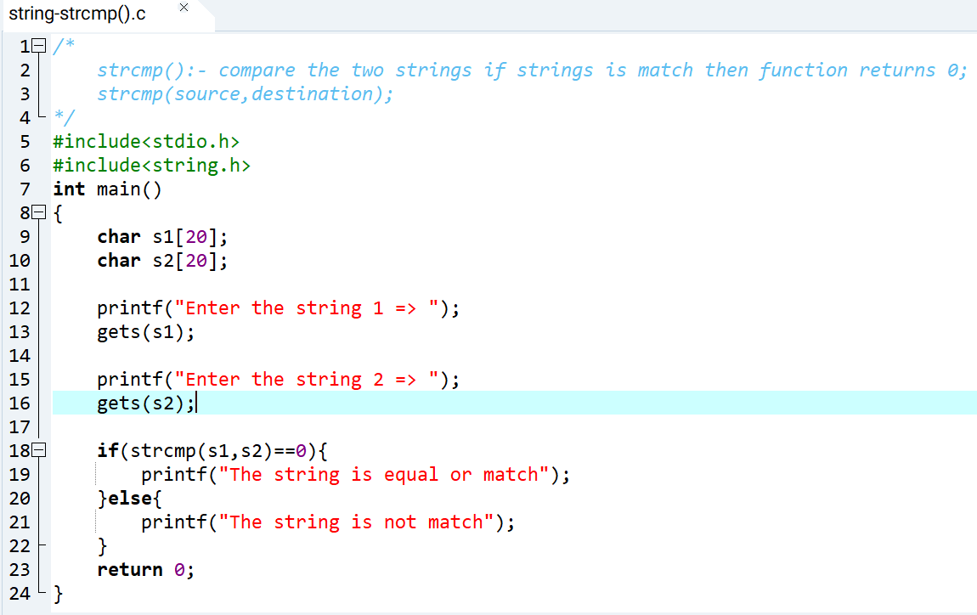
Output:-
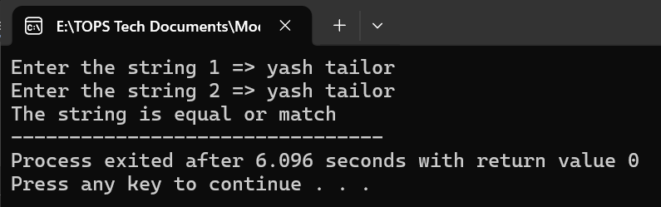
- Strchr():- It is used to locate first occurrence of a specified character within a string.
Example:-
Input:-
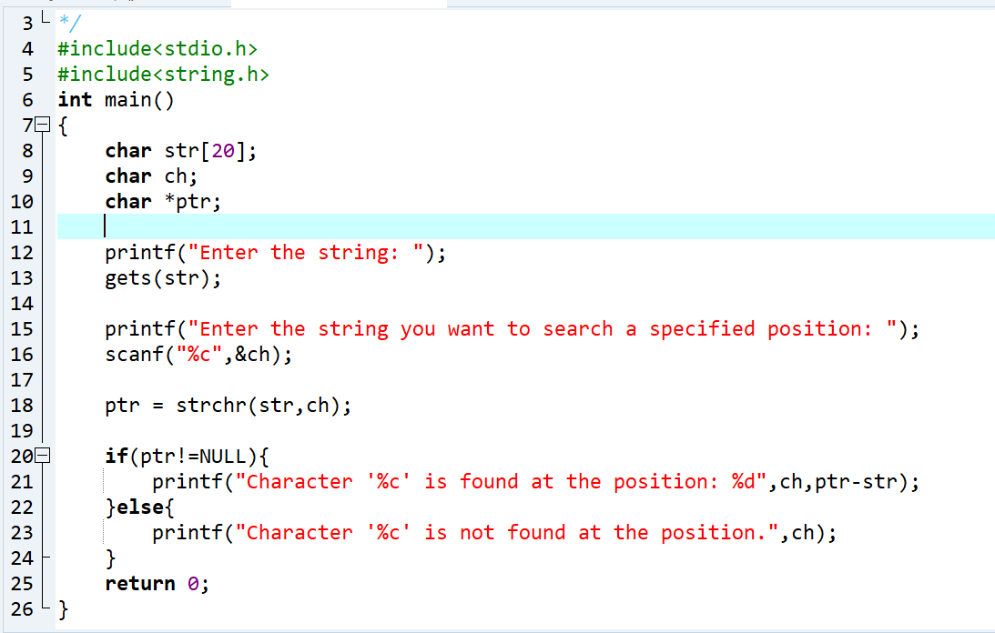
Output:-
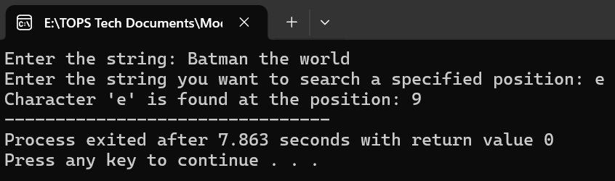

- Write a C program that takes two strings from the user and concatenates them using strcat(). Display the concatenated string and its length using strlen(). - LAB EXERCISE
- Input:-
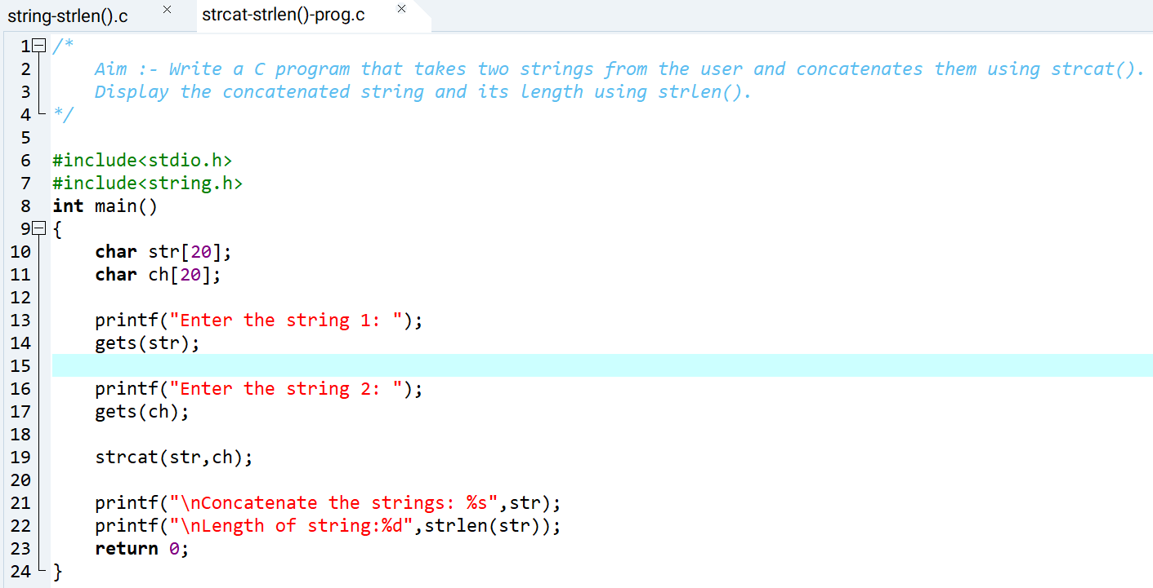
Output:-
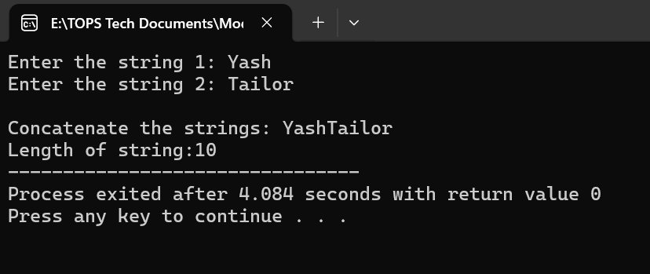
- Explain the concept of structures in C. Describe how to declare, initialize, and access structure members.
- A structure in C user-defined data type that allow you to group variable of different data types under a single name
- Declaring a Structure:-
Struct structure_name{
Datatype_member1;
Datatype_member2;
Datatype_member3;
};
- How to create structure variable :-
struct Student s1, s2;
- How to Initialize a Structure :-
struct Student s1 = {1, "Yash", 85.5};
- How to Access Structure Members :-
Using Dot Operator (.)
printf("%d", s1.roll_no);
printf("%s", s1.name);
printf("%.2f", s1.marks);

- Write a C program that defines a structure to store a student's details (name, roll number, and marks). Use an array of structures to store details of 3 students and print them. - LAB EXERCISE
- Input:-
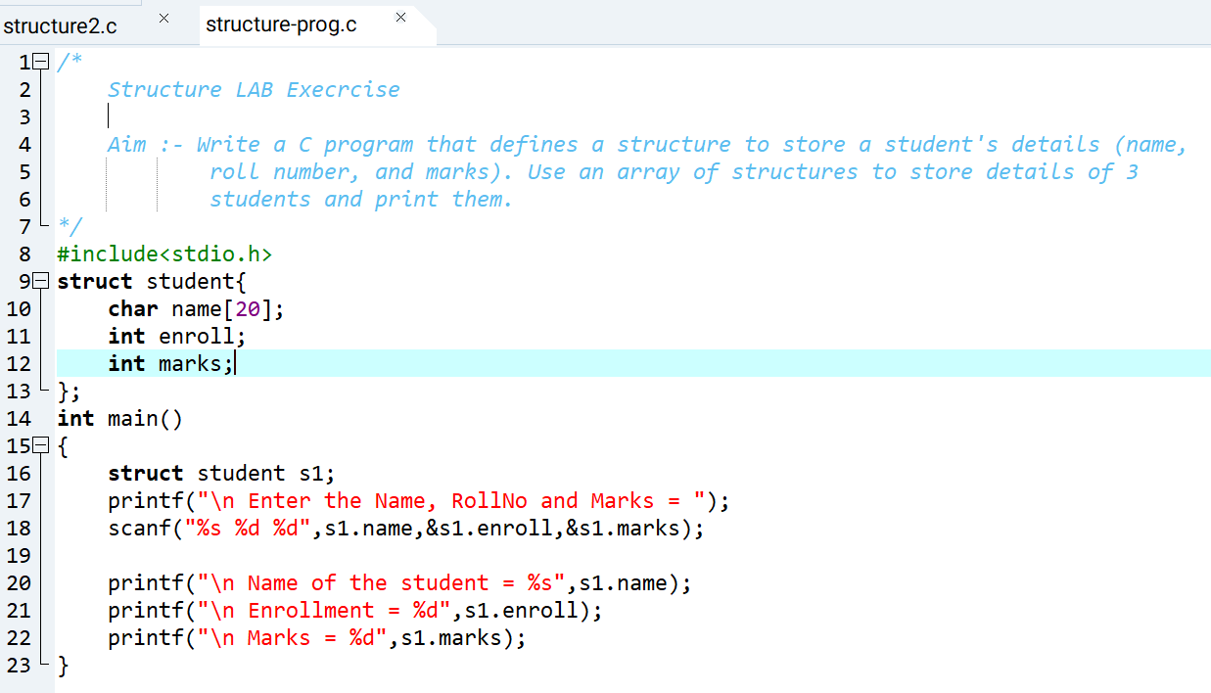
Output:-
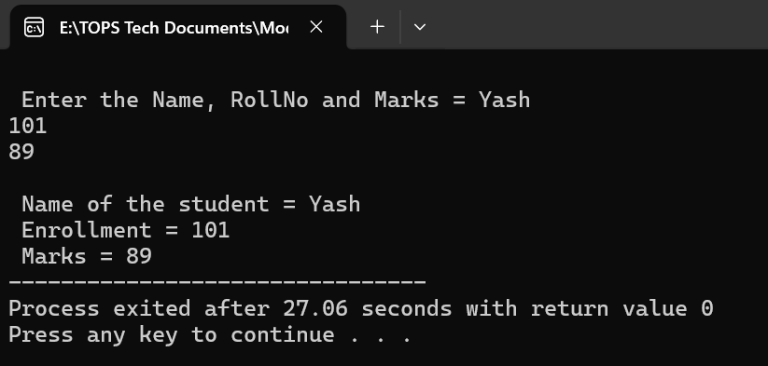
- Explain the importance of file handling in C. Discuss how to perform file operations like opening, closing, reading, and writing files.
- There are below the importance of file handling :-
- Permanent Storage :- Data is saved even after program ends.
- Handles Large Data :- Store large information outside memory.
- Data Sharing :- Multiple programs can use the same file.
- Record Keeping :- useful in database, logs, reports etc.
- Steps in File Handling :-
- Declare in File pointer :-
FILE *fp;
- Open the file – fopen()
fp = fopen("test.txt” , ”w”);
common modes :-
“r” = read
“w” = write
“a” = append
- Write to File :-
fprintf(fp,“text”);
fputs(“text”,fp); => string write
fputc(‘A’ , fp); => single character passes
- Read From File :-
fscanf(fp , “%s”, str);
fgets(str, size, fp);
fgetc(fp);
- Close the file :-
fclose(fp);
- Example :-
- Input :-
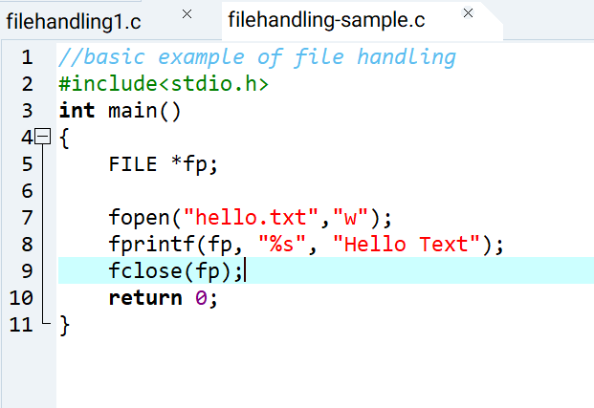
- Write a C program to create a file, write a string into it, close the file, then open the file again to read and display its contents.
- Input :-
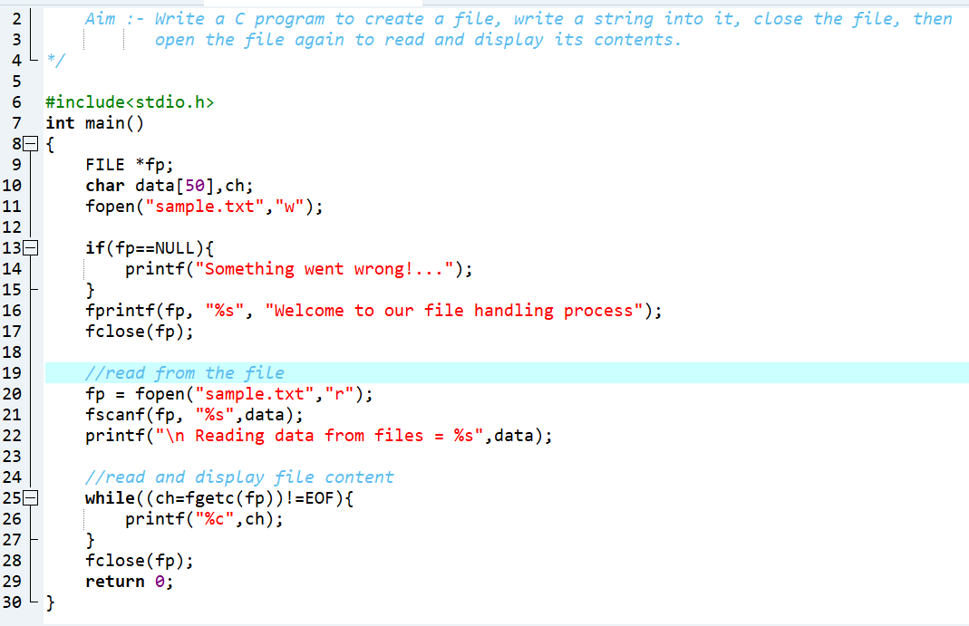

- Output:-
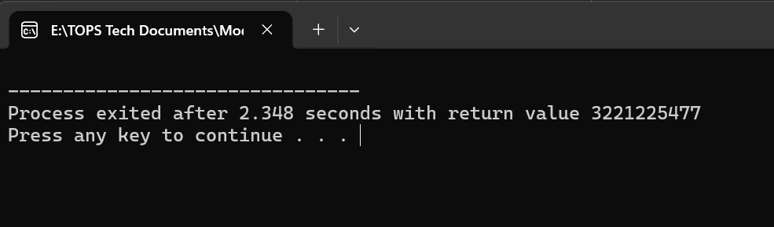

- File created sample.txt

